С++ & SFML

SAO: The Platformer

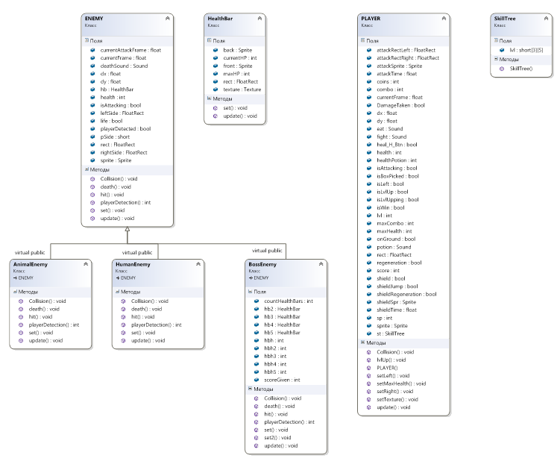

Class Diagramm

